**APPLICATION DEVELOPMENT – I**

**Software requirements specification**

*Submitted in partial fulfilment for the award of the degree*

*of*

**Master of Science**

***in***

**Information Technology**

*by*

**Kalyani Payyavula**

**(15MIN0241)**



**School of Information Technology and Engineering**

June, 2019

**CONSULT DOCTOR ONLINE**

Software Requirements Specification

1.0

22.06.2019

Kalyani Payyavula

Software Engineer

(EMP.ID - 318562)

Table of Contents

1. Introduction 4

1.1 PURPOSE 4

1.2 SCOPE 5

1.3 DEFINITIONS, ACRONYMS AND ABBREVATIONS 5

1.4 REFERENCES 5

1.5 OVERVIEW 5

2 GENERAL DESCRIPTION 5

2.1 PRODUCT PERSPECTIVE 6

2.2 PRODUCT FUNCTIONS 6

2.3 USER CHARACTERISTICS 6

2.4 GENERAL CONSTRAINTS 10

2.5 ASSUMPTIONS AND DEPENDENCIES 10

3 SPECIFIC REQUIREMENTS 11

3.1 EXTERNAL INTERFACE REQUIREMENTS 11

3.1.1 User Interfaces 11

3.1.2 Hardware Interfaces 11

3.1.3 Software Interfaces 11

3.1.4 Communications Interfaces 11

3.2 FUNCTIONAL REQUIREMENTS 12

3.2.1 Home Page Requirements: 12

3.2.2 New user registration Requirements: 12

3.2.3 Doctor Availability Requirements: 12

3.2.4 Book Appointment Requirements: 13

3.2.5 Check History Requirements: 13

3.2.6 Profile Management Requirements: 14

3.2.7 Doctor Requirements: 14

3.3 BEHAVIOR REQUIREMENT 15

4 NON- FUNCTIONAL REQUIREMENTS 16

4.1 Performance: 16

4.2 Reliability: 16

4.3 Security: 16

4.4 Maintainability: 16

4.5 Portability: 16

5 DATA DESIGN 17

5.1 Sequence Diagram 17

5.2 Data Flow Diagrams (DFD) 18

5.3 E-R Diagram 19

# 

# Introduction

As the population continues to grow, so does the need for healthcare services. Exponential increase in the number of patients, creates new challenges for facility administrators and staff. Legacy processes and procedures that clinics followed may no longer be effective in handling a raise in new patients. One process affected almost every patient and doctor from an increase in patients is appointment-scheduling. This seemingly simple task can quickly become burdensome and challenging to staff members. Most of the clinics and doctors tend to do scheduling appointment over the phone which consumes most of the time and resources. In the next few years most of the individuals prefer to do common tasks online instead of picking up the phone and calling doctor.

Few benefits of online appointment are Time Savings, Monetary Saving and 24 -hour convenience. Let’s take simple example of clinic which does 100 appointments daily on phone. Each appointment call can take an average of 4 minutes which result in 400 minutes or seven hours. One staff member is dedicated to take appointments. Both time and expense required for this staff member can be saved. Sending automated remainders to patients helps to decrease the number of ‘no-shows’. This can directly impact on the revenue of the clinic. Scheduling appointments over the phone usually requires an individual to phone in during office hours. This can cause inconvenience for most patients, as they too are working at this time. An online scheduling system allows for 24-hour scheduling, not just during normal facility of office hours.

Facilities or Clinics with younger patients and clients can have an easy transition to online-appointment, as this group is typically internet savvy and actually prefer to schedule appointments online. On the other hand, hospitals with large number of senior patients and clients would not have an that easy transition to online appointment. However, few surveys show that Internet users in the age group of 50-64 grew exponentially day by day. In order to address the group which doesn’t use internet, clinics may continue to do phone appointment for few more years.

## PURPOSE

In my observation almost, all clinics or doctors are trying to solve the same problem, allow patients to book appointments round the clock. I would like to provide a common solution which can solve the problem of all patients and doctors. Provide a configurable application which can be configured for a particular clinic or doctor. Allow administrator to add/delete doctors to the clinic. Patients should be able to book appointment right from the mobile browser or desktop browser. Scheduling appointment online can benefit everyone involved in the scheduling process, as administrators and staff can conduct their task more efficiently and accurately, while customers and clients have the ability to book their appointments and reservations quickly and more conveniently.

## SCOPE

This document will cover requirements on allowing users to book doctor appointments online. This covers both functional and non-functional aspects of the use case. In the functional scope it covers about the use case of patient, doctor and clinic admin. It covers in detail about how the application allows users to register, login and book appointments. It also covers about how users can check the history of the appointments. To make the use case complete this talk about how users can cancel/edit the appointments which are already in place.

In the non-functional aspects of the use case this document talks about how to avoid hackers to make appointment. This covers on how the system should be build robust so that it won’t execute the scripts injected by hackers. This also covers requirements on system performance, portability and saving user identity.

This document doesn’t speak about the design or technical aspects of the implementation. For more information on design, implementation and testing, I would recommend to refer respective documents.

## DEFINITIONS, ACRONYMS AND ABBREVATIONS

FR – Functional Requirements

NFR – Non Functional Requirements

NURR – New User Registration Requirements

DAR – Doctor Availability Requirements

BAR – Book Appointment Requirements.

PM – Profile Management

CH – Check History

## REFERENCES

|  |  |
| --- | --- |
| Reference |  |
| Document location | <https://github.com/KalyaniPayyavula/consult_doctor/tree/master/documents> |
| Design, Implementation & Testing documents | <https://github.com/KalyaniPayyavula/consult_doctor/tree/master/documents> |
| Apollo Appointment | <https://www.askapollo.com/physical-appointment/> |
| Manipal Appointment | <https://www.manipalhospitals.com/appointments> |
| Sakra Hospital Appointment | <https://www.sakraworldhospital.com/request-appointment.php> |
| Online appointments | <https://www.appointmentplus.com/> |

## OVERVIEW

The rest of this document contains the following in the mentioned order:

* General description of the project and its requirements.
* Specific requirements for the project including the functionality, usability, reliability, performance security, safety, design constraints, etc.
* Supporting information in order to understand the project including diagrams which represent the system.

# GENERAL DESCRIPTION

The appointment-scheduling process, historically viewed as a necessary burden in medical offices, healthcare facilities and wellness centers, can be completely automated through an inefficient online scheduling software program. The benefits of implementing this technology touch everyone involved in the scheduling process, as administrators and staff can conduct their tasks more efficiently and accurately, while customers and clients have the ability to book their appointments and reservations quickly and more conveniently.

The Benefits of an Online Scheduling System:

Commonly referred to by such names as online scheduling software, online booking applications and online scheduler, an online scheduling system is a Web-based application that allows individuals to conveniently and securely book their appointments and reservations online through any Web-connected device, such as a computer, laptop, smartphone or tablet. They typically access the online scheduling system through a “Book Now” button found on a Web site or page, or from a URL provided to them by the medial, healthcare or wellness facility. Once a date and time are selected, the system will automatically confirm the booking and instantly record it within the system, without any staff action needed.

In addition to online scheduling, online scheduling systems also come equipped with other beneficial features like automated e-mail and text message reminders, which the system sends out to patients and booked individuals on a specific date prior to their scheduled appointment; recording and record-keeping capabilities that make it quick and simple to access data associated with a specific appointment; and repeat patient reminders, which the system sends out automatically when a specified amount of time has expired between appointments.

24-Hour Convenience:

Scheduling appointments over the phone usually requires an individual to phone in during office hours, as few facilities offer round-the-clock phone booking. This is an inconvenience for most patients, as they too are working at this time. Additionally, many individuals prefer to schedule their appointments online rather than over the phone. An online scheduling system allows for 24-hour scheduling, not just during normal facility or office hours.

Time savings:

Staff spends less time on the phone booking and managing appointments, thereby freeing up their schedule for more important and pressing tasks. Booking individuals also save time, as they no longer have to commit a part of their busy schedule to calling their medical, healthcare or wellness provider (or remain on hold, which adds minutes to the scheduling process).

As an example, let’s look at a large medical facility that typically schedules approximately 100 appointments daily. Each appointment call is fielded by an administrative support staffer, who spends an average of four minutes on the phone. This equates to an average of 400 minute or almost seven hours of time spend each day just to booking appointments over the phone.

That’s time savings just from scheduling appointments alone. Other tasks automated by an online scheduling system, such as automated appointment reminders, add additional time savings to daily operations.

## PRODUCT PERSPECTIVE

This could have an effect on the success of an online scheduling system whose goal is to provide online scheduling. Facilities, centers and practices with younger patients and clients may have an easy transition, as this group is typically Internet savvy and actually prefer to schedule appointments online. On the other end of the spectrum are sites with a large number of senior patients and clients. Although the initial determination may be that this group would not have an interest in scheduling online, a Pew Research Center Internet and American Life Project survey shows that social networking among Internet users ages 50-64 grew 88 percent—from 25 percent to 47 percent—from April 2009 to May 2010, while use among those ages 65 and older grew 100 percent from 13 percent to 26 percent during that same period. However, there still exists a significant percentage in this group that may not be comfortable scheduling online, which should be a consideration when determining how to best utilize a scheduling system (such as whether or not to require online appointments from patients). Case in point, a Pew Internet survey showed that, as of January 2009, 38 percent of U.S. adults age 65 and older go online, a much lower rate of Internet adoption than the general population percentage of 74 percent.

HIPAA compliance. Given the online interaction and transfer of information between a facility and its patients, compliance of Health Insurance Portability and Accountability Act (HIPAA) provisions is an important consideration when utilizing an online scheduling system. On the operational procedures end, the facility should have strong internal policies regarding patient and customer information. In essence, the software itself should give the facility the ability to be HIPAA-compliant and provide it with the ability to adjust settings and preferences to ensure that this data is secured.

## PRODUCT FUNCTIONS

A variety of online scheduling applications are available on the market today. However, they vary greatly in the types of features, functionality and services offered. Due diligence and research should be conducted when selecting an appointment scheduling software provider, given the important role in could play in the operations of healthcare, medical or wellness facility. Common considerations include:

Due diligence and research should be conducted when selecting an appointment scheduling software provider, given the important role in could play in the operations of healthcare, medical or wellness facility.

Features and functionality. Although some features and functionality come standard with some scheduling systems, they can vary widely among the many service providers. A current analysis of both current and future needs can help facilities in the selection process. Creating a specified workflow typically requires the most time in the analysis process, and a provider should utilize the services of a team of specialists experienced with multiple variations of scheduling processes.

Professional services. Medical, healthcare and wellness facilities oftentimes have unique scheduling needs that stretch beyond the standard functionality of the system, as stated in the above. This is especially true of facilities with multiple locations, large numbers of staff and patients/customers, and a high volume of appointments. Many providers do not offer the professional services necessary to accommodate these needs. Inquire on what the provider currently offers and its limitations for customization and advanced services.

Security. As mentioned in the HIPAA compliance section above, security is a must when it comes to an online scheduling system. Reputable providers incorporate the latest security measures and practices, such as secure server databases, data storage and back-up procedures, processes related to failover and federal regulations, as well as the aforementioned HIPAA-compliant practices.

## USER CHARACTERISTICS

There are many eventual users who will use my application. The general characteristics of the eventual users of the product that will affect the specific requirements are as below:

1. **New Patient:** New Patient is someone who is approaching doctor or facility for the first time.

Functionalities:

* Register himself with all personal details.
* Check doctor availability and book appointment.
* Check history of appointments.
* Edit/ delete appointments already made.
* Edit his personal profile.
* Take appointment for his/her family member.

1. **Doctor:**  User authorized by admin as doctor.

Functionalities:

* Updates his/her availability.
* Can have access to patient details who has taken appointment.
* Mark appointment as completed/handled.
* Give future appointments for patients.
* Ability to cancel appointments on emergency.

1. **Admin:**  User authorized to add doctor profile and generate access credentials for doctors.

Functionalities:

* Updates list of doctors available in the clinic.
* Has permissions to add/remove doctors.
* Controls appointment remainders.
* Maintains the system and sole responsible for maintaining appointments.

## GENERAL CONSTRAINTS

While the actual implementation of an online scheduling system is typically seamless and relatively simple, there are considerations that medical, healthcare and wellness facilities should keep in mind when transitioning to Web-based booking. They include:

Optional or required? One question administrator should answer is whether or not to make online scheduling a requirement. Requiring that all appointments be made online can certainly free up staff responsibilities and schedules, but it can also be a hindrance to those without easy access to the Internet or who prefer to schedule their appointments over the phone. Many facilities give their patients and clients the option of booking online, which typically brings good results.

## ASSUMPTIONS AND DEPENDENCIES

* Each facility has a technical person who can manage the application.
* Admin will not remove/add list of doctors on his own wish.
* This application needs user with internet connection.
* Doctors don’t make sudden surprise to patients by cancelling the appointments.
* Patients who don’t make the appointments on time should be given opportunity in the next available slot.

# SPECIFIC REQUIREMENTS

## EXTERNAL INTERFACE REQUIREMENTS

### User Interfaces

* System shall provide browser interface to use the system.
* Application shall launch successfully in all popular browsers like IE, Google Chrome, Safari and Firefox.
* System shall also allow users to use Mobile browsers.
* System shall work fine with Android and iOS default browsers.

### Hardware Interfaces

* Application shall not take any input from hardware.
* Application shall save data to database only on valid session.
* Application shall not allow any external hardware to read user data.
* This system doesn’t read/write data to any hardware.

### Software Interfaces

* System shall not accept data from any external software.
* System shall write data to database server.
* System shall read data form database server after successful authentication.

### Communications Interfaces

* System shall communicate with database to store user details and doctor details.
* User details are only available to doctor with read access.
* User is the only interface which inserts data into the system.
* Doctor can only read the data of user, he cannot modify it.

## FUNCTIONAL REQUIREMENTS

### Home Page Requirements:

|  |  |
| --- | --- |
| Requirement ID | Requirement |
| FR-HomePage-1 | System shall display list of doctors and their specialization. |
| FR-HomePage-2 | List of doctors available in a clinic can be edited / modified. |
| FR-HomePage-3 | Home page should include doctor timings, doctor qualifications. |
| FR-HomePage-4 | Home page shall display a link to check availability of particular doctor. |
| FR-HomePage-5 | Home page shall display an option to register new user. |
| FR-HomePage-6 | Home page shall allow already registered user to login. |
| FR-HomePage-7 | Home page shall allow Guest user to check his Appointments. |

### New user registration Requirements:

|  |  |
| --- | --- |
| Requirement ID | Requirement |
| FR-NURR-1 | System shall allow user to register with his personal details so that he can use them later to book appointment. |
| FR-NURR-2 | System shall ask for following details.   * User Id * * Password* * Confirmation password* * Email* * Mobile Number* * Address: Line 1, Line 2, Pin Code   Fields marked with * are mandatory. |
| FR-NURR-3 | System shall validate user provided details and provide a confirmation message to the user. |

### Doctor Availability Requirements:

|  |  |
| --- | --- |
| Requirement ID | Requirement |
| FR-DAR-1 | System shall display list of available dates with green color. |
| FR-DAR-2 | On selecting a date with green color, system shall display an overlay to the user with list of available Slots. |
| FR-DAR-3 | System shall allow user to check doctor availability for next 3 months. |
| FR-DAR-4 | If doctor is not available for any reason system shall display such reason on the screen. |

### Book Appointment Requirements:

|  |  |
| --- | --- |
| Requirement ID | Requirement |
| FR-BAR-1 | System shall allow user to pick an available slot and proceed with appointment booking. |
| FR-BAR-2 | System shall block a slot for a user and doesn’t show that slot for any other user. |
| FR-BAR-3 | System shall allow user to book appointment even without login as guest user. |
| FR-BAR-4 | Guest user will be asked to enter details like  Name*  Mobile number*  Email id*  Problem description*  Address:  Fields marked with * are mandatory. |
| FR-BAR-5 | System shall allow registered user to login and book appointment. In this use case System shall pick user details directly. |
| FR-BAR-6 | System shall display an option to select if the appointment is for his/her family member. |
| FR-BAR-7 | When user selects family member option he will be asked to enter the details of family member. |
| FR-BAR-8 | Family details shall be saved by the system so that they will not be asked to enter again. |
| FR-BAR-9 | Each slot shall be 15 mins. This should be configurable by doctor. |
| FR-BAR-10 | Each user can book a maximum of 2 appointments per doctor. |

### Check History Requirements:

|  |  |
| --- | --- |
| Requirement ID | Requirement |
| FR-CH-1 | System shall allow registered user to check his history of appointments. |
| FR-CH-2 | If an appointment is in future user will be allowed to edit/cancel that appointment. |
| FR-CH-3 | When user cancel an appointment, it will be made available to other users for use. |
| FR-CH-4 | If user wishes to edit the time of appointment user shall be presented with available slots in the same page. |
| FR-CH-5 | When user cancel appointment, free the slot. |

### Profile Management Requirements:

|  |  |
| --- | --- |
| Requirement ID | Requirement |
| FR-PM-1 | System shall allow user to check his profile. |
| FR-PM-2 | System shall allow user to edit his profile if user feels so. |
| FR-PM-3 | System shall allow user to add his family members details. |
| FR-PM-4 | User can never change his user id once registered. |

### Doctor Requirements:

|  |  |
| --- | --- |
| Requirement ID | Requirement |
| FR-DR-1 | System shall allow admin to add doctor to clinic. |
| FR-DR-2 | Once doctor is added to clinic he/she will be provided login credentials with which they are allowed to enter their availability in the clinic. |
| FR-DR-3 | System shall allow doctor to check his filled slots for the next 3 months. |
| FR-DR-4 | System shall allow doctor to check the profile of the patient. |
| FR-DR-5 | System shall allow doctor to enter notes about the patient findings. |
| FR-DR-6 | System shall allow doctor to check previous visits of the patient and his findings. |

## BEHAVIOR REQUIREMENT

* **Use Case Diagram**

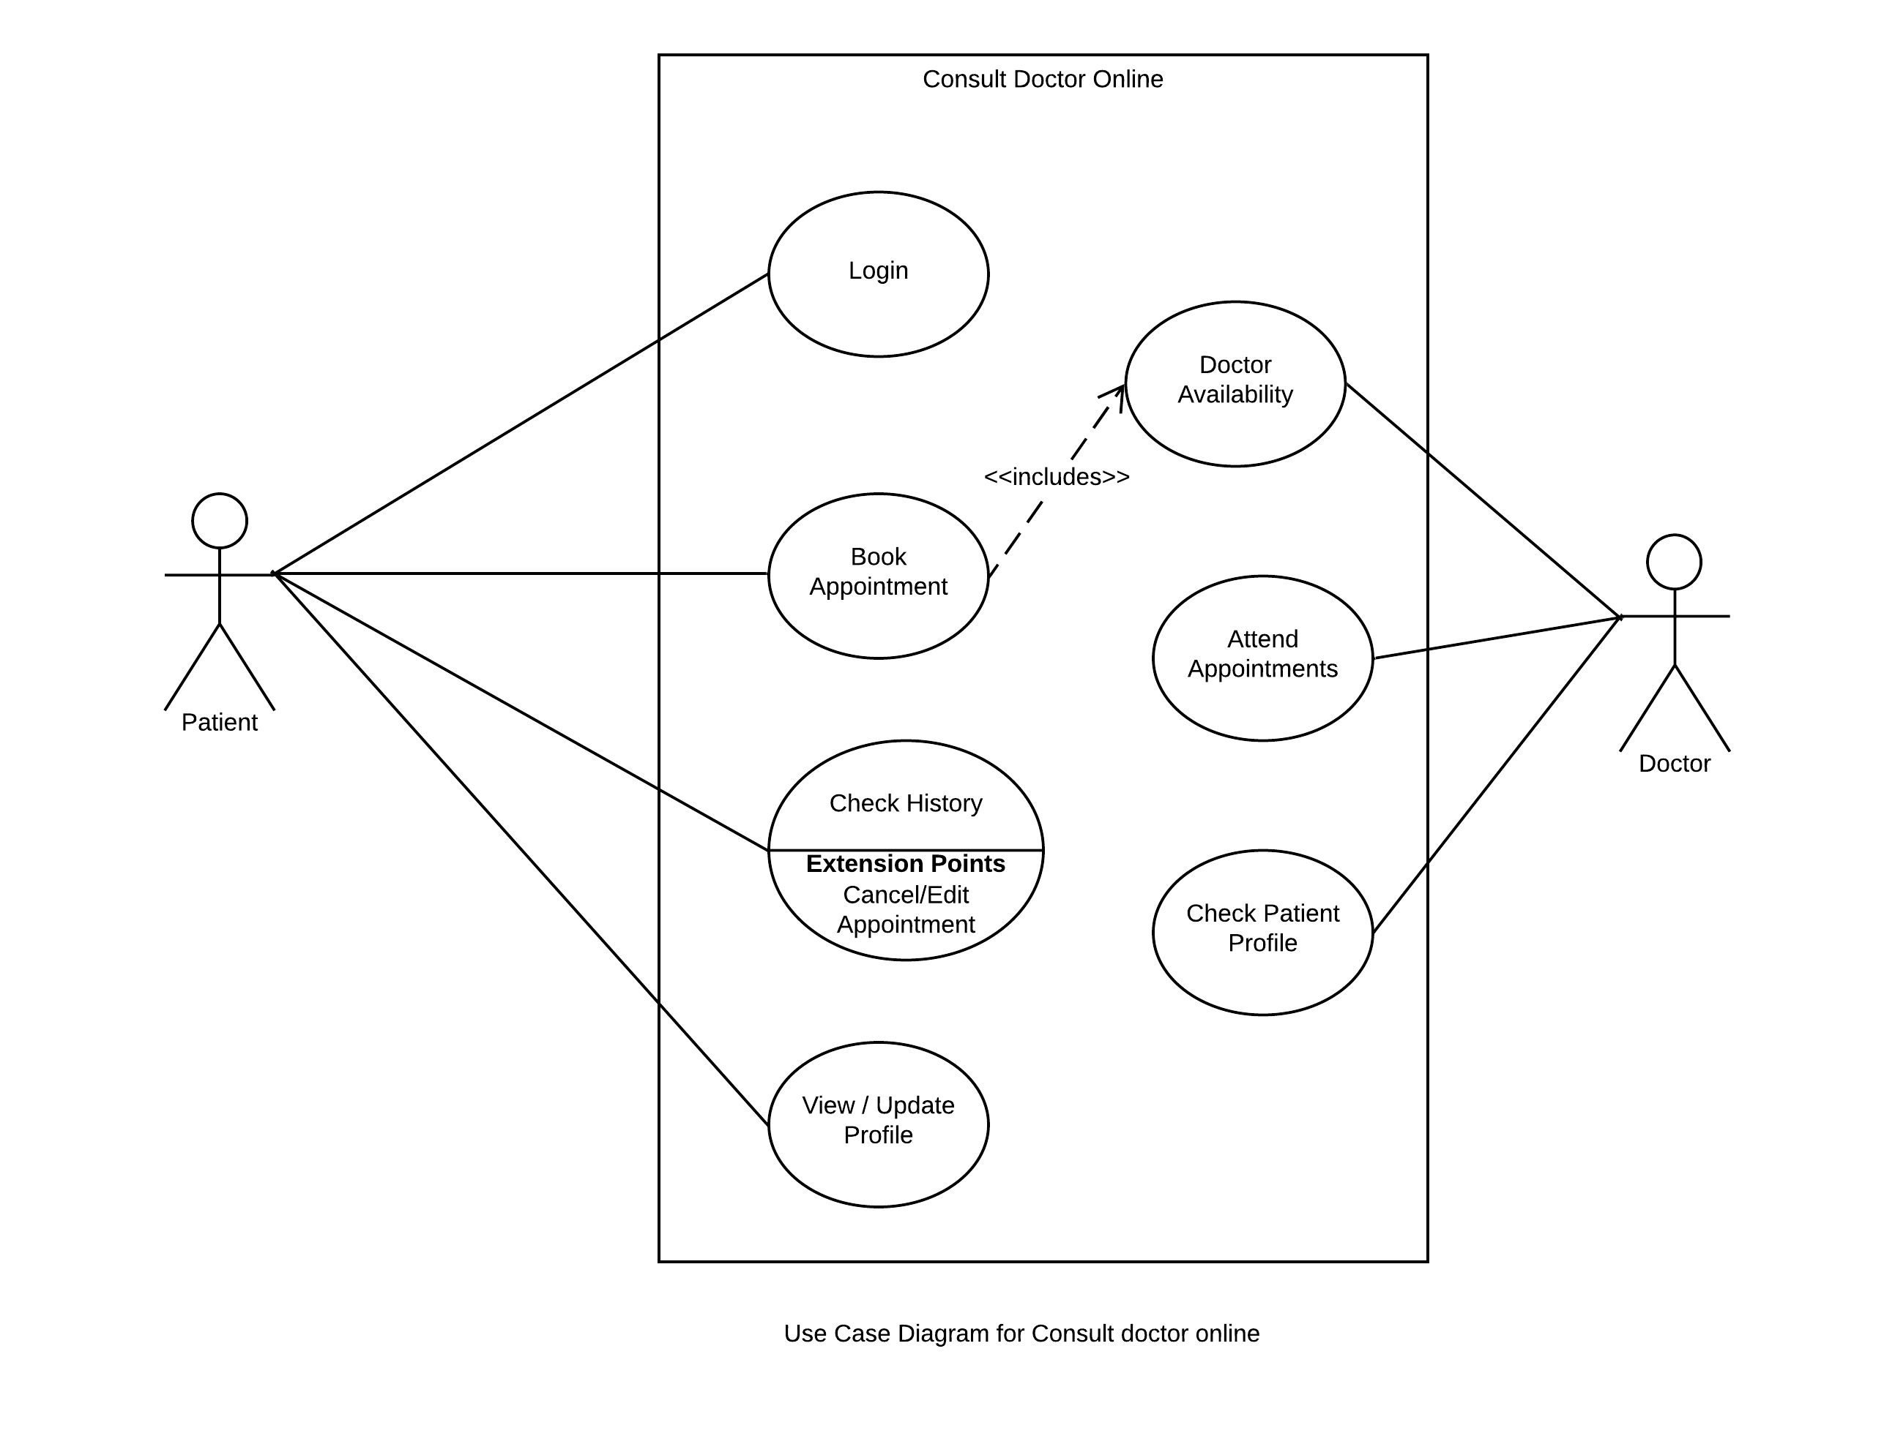

# NON- FUNCTIONAL REQUIREMENTS

A non-functional requirement is a [requirement](https://en.wikipedia.org/wiki/Requirement) that specifies criteria that can be used to judge the operation of a system, rather than specific behaviors. Non-functional requirements place restrictions on the product being developed, the development process, and specify external constraints that the product must meet.

## Performance:

|  |  |
| --- | --- |
| NFR-Perf-1 | Application shall launch in no less than 1 seconds on good internet connection. |
| NFR-Perf-1 | User doesn’t see any lag while checking the doctor availability. |
| NFR-Perf-1 | Application shall launch in mobile browsers with no lag. |
| NFR-Perf-1 | Application shall perform well on Smart phones with 3G connections as well. |

## Reliability:

|  |  |
| --- | --- |
| NFR-Reli-1 | Application must be robust enough to make sure that their data is not compromised. |
| NFR-Reli-2 | Only doctor can check the data of the patient. |
| NFR-Reli-3 | Office staff shall not have access to the patient problem statement. |
| NFR-Reli-4 | If a family member books an appointment for his children he can access the data. |

## Security:

|  |  |
| --- | --- |
| NFR-Secu-1 | Application should avoid hackers to book appointment. |
| NFR-Secu-2 | Application Must take care that no scripts can be inserted as input. |
| NFR-Secu-3 | Application Must not execute user inputs directly on the database. |
| NFR-Secu-4 | Application shall not allow hacker to access the database. |

## Maintainability:

|  |  |
| --- | --- |
| NFR-Main-1 | Application should be built in such a way that it can be maintained with minimum cost. |
| NFR-Main-2 | Adding new features to the application should be with minimum cost. |
| NFR-Main-3 | Application should be robust enough to upgrade the libraries. |

## Portability:

|  |  |
| --- | --- |
| NFR-Port-1 | Application can be launched on different desktop browsers. |
| NFR-Port-2 | Application shall adapt well with mobile browsers. |
| NFR-Port-3 | All popular browsers can launch the application. |
| NFR-Port-4 | Application can be converted to mobile application with minimum cost. |

# DATA DESIGN

## Sequence Diagram

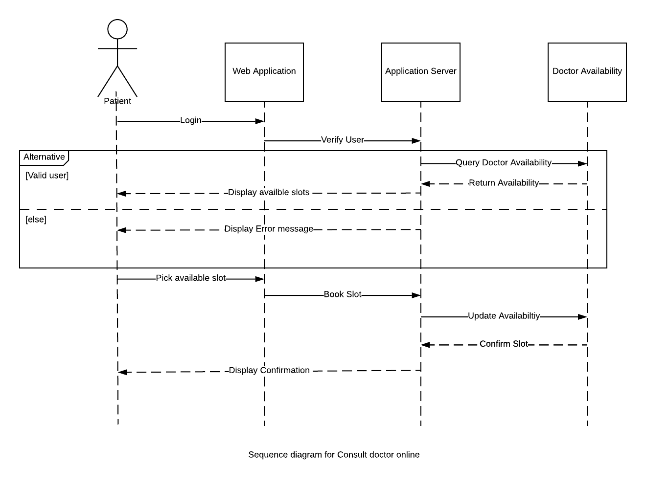

## Data Flow Diagrams (DFD)

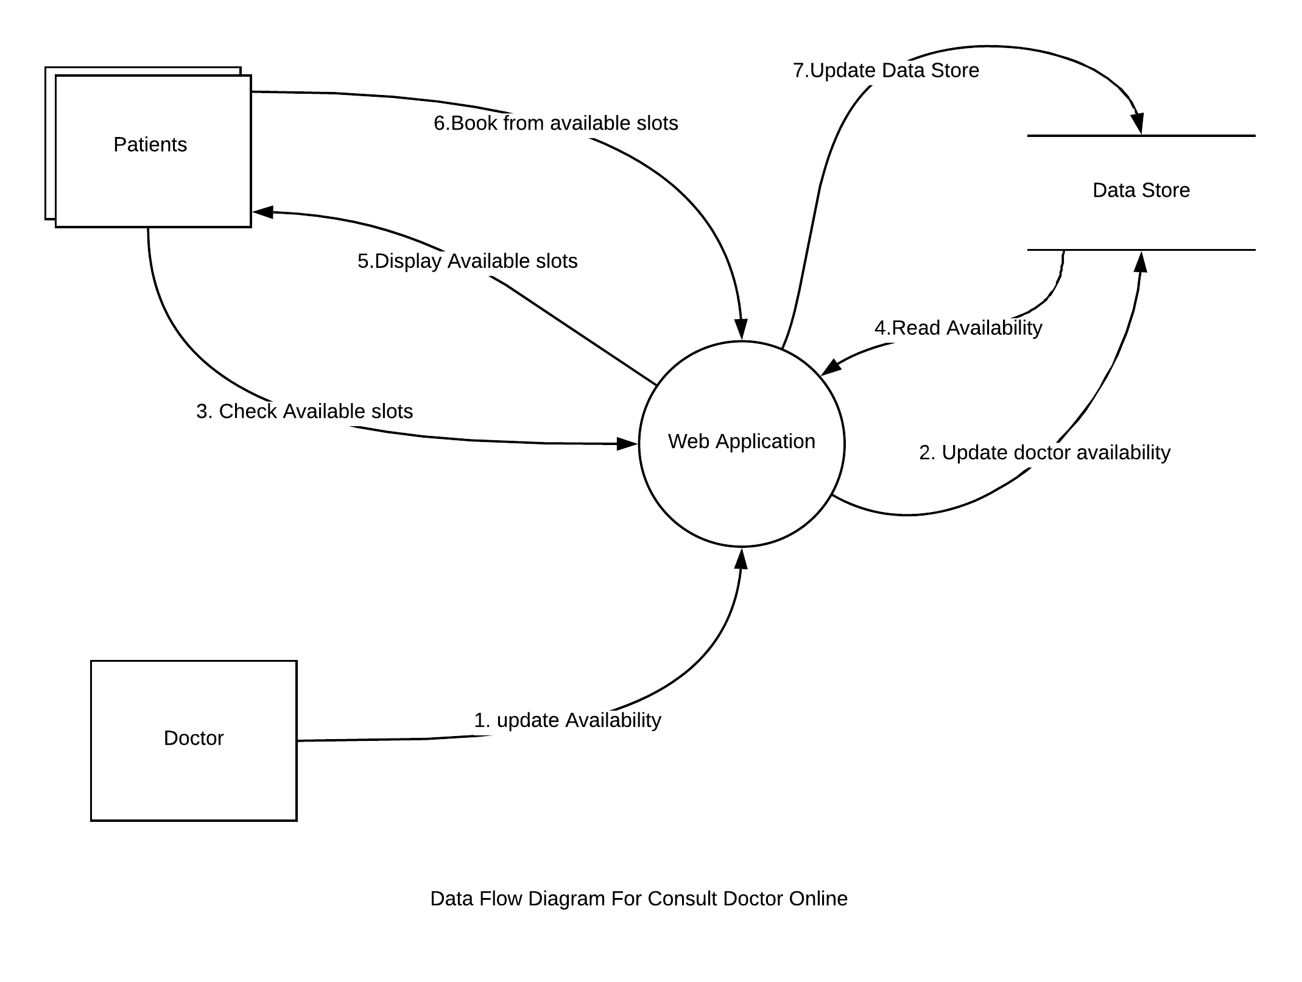

## E-R Diagram

